NIM : 245410034
Nama : Irvan Cahya Nugraha
Kelas : IF-1

LISTING PRAKTIKUM STRUKTUR DATA
MODUL 10
DOUBLE LINKEDLIST ( SENARAI BERANTAI GANDA )

PRAKTIK
Praktik 1

import java.util.Scanner;

class simpul {
String nama;
String alamat;
int umur;
char jekel;
String hobi[] = new String[3];
float ipk;
simpul kiri;
simpul kanan;
}

class senaraiGanda {
public static simpul awal;
public static simpul akhir;

public static void inisialisasiSenaraiKosong() {
awal = null;
akhir = null;
}

public static void tambahDepan() {
Scanner masukan = new Scanner(System.in);
int bacaTombol = 0;

System.out.println("TAMBAH DEPAN : ");
System.out.print("Silakan masukkan nama anda : ");
String NAMA = masukan.nextLine();
System.out.print("Silakan masukkan alamat anda : ");
String ALAMAT = masukan.nextLine();
System.out.print("Silakan masukkan umur anda : ");
int UMUR = masukan.nextInt();
System.out.print("Silakan masukkan jenis Kelamin anda : ");
try {
bacaTombol = System.in.read();
} catch (java.io.IOException e) {
}
char JEKEL = (char) bacaTombol;
masukan.nextLine(); // membersihkan newline

System.out.println("Silakan masukkan hobi (maks 3) : ");
System.out.print("hobi ke-0 : ");
String HOBI0 = masukan.next();
System.out.print("hobi ke-1 : ");
String HOBI1 = masukan.next();
System.out.print("hobi ke-2 : ");
String HOBI2 = masukan.next();
System.out.print("Silakan masukkan IPK anda : ");
float IPK = masukan.nextFloat();

simpul baru = new simpul();
baru.nama = NAMA;
baru.alamat = ALAMAT;
baru.umur = UMUR;
baru.jekel = JEKEL;
baru.hobi[0] = HOBI0;
baru.hobi[1] = HOBI1;
baru.hobi[2] = HOBI2;
baru.ipk = IPK;

if (awal == null) {
awal = baru;
akhir = baru;
baru.kiri = null;
baru.kanan = null;
} else {
baru.kanan = awal;
awal.kiri = baru;
awal = baru;
awal.kiri = null;
}
}

public static void tambahBelakang() {
Scanner masukan = new Scanner(System.in);
int bacaTombol = 0;

System.out.println("TAMBAH BELAKANG : ");
System.out.print("Silakan masukkan nama anda : ");
String NAMA = masukan.nextLine();
System.out.print("Silakan masukkan alamat anda : ");
String ALAMAT = masukan.nextLine();
System.out.print("Silakan masukkan umur anda : ");
int UMUR = masukan.nextInt();
System.out.print("Silakan masukkan Jenis Kelamin anda : ");
try {
bacaTombol = System.in.read();
} catch (java.io.IOException e) {
}
char JEKEL = (char) bacaTombol;
masukan.nextLine();

System.out.println("Silakan masukkan hobi (maks 3) : ");
System.out.print("hobi ke-0 : ");
String HOBI0 = masukan.next();
System.out.print("hobi ke-1 : ");
String HOBI1 = masukan.next();
System.out.print("hobi ke-2 : ");
String HOBI2 = masukan.next();
System.out.print("Silakan masukkan IPK anda : ");
float IPK = masukan.nextFloat();

simpul baru = new simpul();
baru.nama = NAMA;
baru.alamat = ALAMAT;
baru.umur = UMUR;
baru.jekel = JEKEL;
baru.hobi[0] = HOBI0;
baru.hobi[1] = HOBI1;
baru.hobi[2] = HOBI2;
baru.ipk = IPK;

if (awal == null) {
awal = baru;
akhir = baru;
baru.kiri = null;
baru.kanan = null;
} else {
baru.kiri = akhir;
akhir.kanan = baru;
akhir = baru;
akhir.kanan = null;
}
}

public static int hitungJumlahSimpul() {
int N = 0;
simpul bantu = awal;
while (bantu != null) {
N++;
bantu = bantu.kanan;
}
return N;
}

public static void tambahTengah() {
Scanner masukan = new Scanner(System.in);
System.out.println("Tentukan Lokasi Penambahan Data");
int LOKASI = masukan.nextInt();
masukan.nextLine();

int jumlahSimpulYangAda = hitungJumlahSimpul();
if (LOKASI == 1) {
System.out.println("Lakukan penambahan di depan");
} else if (LOKASI > jumlahSimpulYangAda) {
System.out.println("Lakukan penambahan di belakang");
} else {
System.out.println("TAMBAH TENGAH : ");
System.out.print("Silakan masukkan nama anda : ");
String NAMA = masukan.nextLine();
System.out.print("Silakan masukkan alamat anda : ");
String ALAMAT = masukan.nextLine();
System.out.print("Silakan masukkan umur anda : ");
int UMUR = masukan.nextInt();
System.out.print("Silakan masukkan Jenis Kelamin anda : ");
int bacaTombol = 0;
try {
bacaTombol = System.in.read();
} catch (java.io.IOException e) {
}
char JEKEL = (char) bacaTombol;
masukan.nextLine();

System.out.println("Silakan masukkan hobi (maks 3) : ");
System.out.print("hobi ke-0 : ");
String HOBI0 = masukan.next();
System.out.print("hobi ke-1 : ");
String HOBI1 = masukan.next();
System.out.print("hobi ke-2 : ");
String HOBI2 = masukan.next();
System.out.print("Silakan masukkan IPK anda : ");
float IPK = masukan.nextFloat();

simpul bantu = awal;
int i = 1;
while (i < LOKASI && bantu != akhir) {
bantu = bantu.kanan;
i++;
}

simpul baru = new simpul();
baru.nama = NAMA;
baru.alamat = ALAMAT;
baru.umur = UMUR;
baru.jekel = JEKEL;
baru.hobi[0] = HOBI0;
baru.hobi[1] = HOBI1;
baru.hobi[2] = HOBI2;
baru.ipk = IPK;

baru.kiri = bantu.kiri;
baru.kiri.kanan = baru;
baru.kanan = bantu;
bantu.kiri = baru;
}
}

public static void hapus() {
if (awal == null) // jika senarai masih kosong
{
System.out.println("senarai kosong, menghapus tidak dapat dilakukan");
} else // jika senarai tidak kosong
{

Scanner masukan = new Scanner(System.in);
System.out.print("Silakan masukkan nama yang ingin dihapus : ");
String NAMACARI = masukan.nextLine();

if (awal == akhir) // jika hanya ada sebuah simpul
{
if (awal.nama.equals(NAMACARI)) {
System.out.println("menghapus " + NAMACARI + " dilakukan..");
inisialisasiSenaraiKosong();
} else
System.out.println("data " + NAMACARI + " tidak ditemukan");
}

else if (awal.nama.equals(NAMACARI))// jika nama ditemukan di awal
{
System.out.println("menghapus " + NAMACARI + " dilakukan..");
awal = awal.kanan;
} else {
simpul bantu;
bantu = awal;
while (bantu.kanan.nama.equals(NAMACARI) == false) {
bantu = bantu.kanan;
if (bantu.kanan == null)
break;
}
if ((bantu == akhir) && (akhir.nama.equals(NAMACARI) == false)) {
System.out.println("data " + NAMACARI + " tidak ditemukan");
} else if (akhir.nama.equals(NAMACARI))// jika nama ditemukan di akhir
{
bantu.kanan = null;
akhir = bantu;
} else {
System.out.println("menghapus " + NAMACARI + " dilakukan..");
bantu.kanan = bantu.kanan.kanan;
}
}
}
}

public static void cetakSenaraiMaju() {
if (awal == null) {
System.out.println("...MAAF SENARAI KOSONG....");
} else {
System.out.println("NO NAMA ALAMAT UMUR JEKEL HOBI[0] HOBI[1] HOBI[2] IPK");
simpul bantu = awal;
while (bantu != null) {
System.out.print(bantu.nama + "\t");
System.out.print(bantu.alamat + "\t");
System.out.print(bantu.umur + "\t");
System.out.print(bantu.jekel + "\t");
System.out.print(bantu.hobi[0] + "\t");
System.out.print(bantu.hobi[1] + "\t");
System.out.print(bantu.hobi[2] + "\t");
System.out.println(bantu.ipk);
bantu = bantu.kanan;
}
}
}

public static void cetakSenaraiMundur() {
if (awal == null) {
System.out.println("...MAAF SENARAI KOSONG....");
} else {
System.out.println("NO NAMA ALAMAT UMUR JEKEL HOBI[0] HOBI[1] HOBI[2] IPK");
simpul bantu = akhir;
while (bantu != null) {
System.out.print(bantu.nama + "\t");
System.out.print(bantu.alamat + "\t");
System.out.print(bantu.umur + "\t");
System.out.print(bantu.jekel + "\t");
System.out.print(bantu.hobi[0] + "\t");
System.out.print(bantu.hobi[1] + "\t");
System.out.print(bantu.hobi[2] + "\t");
System.out.println(bantu.ipk);
bantu = bantu.kiri;
}
}
}

public static void main(String[] args) {
inisialisasiSenaraiKosong();
tambahDepan();
tambahDepan();
tambahBelakang();
tambahBelakang();
tambahTengah();
System.out.println("HAPUS DATA");
hapus();
System.out.println(" ");
System.out.println("CETAK MAJU");
cetakSenaraiMaju();
System.out.println(" ");
System.out.println("CETAK MUNDUR");
cetakSenaraiMundur();
}
}

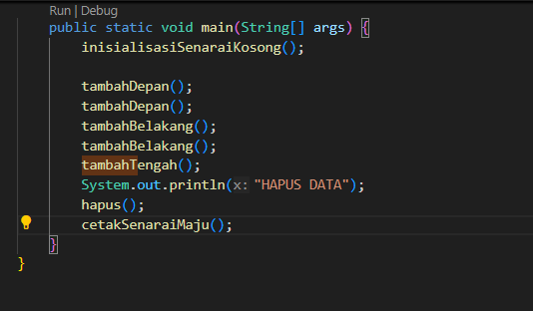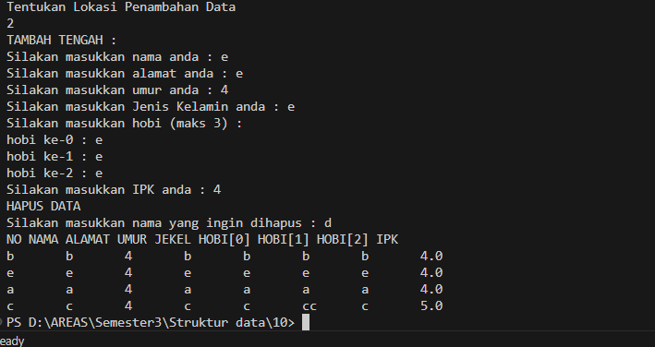

Praktik 2

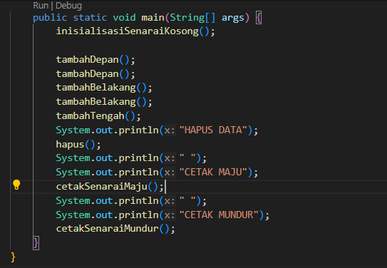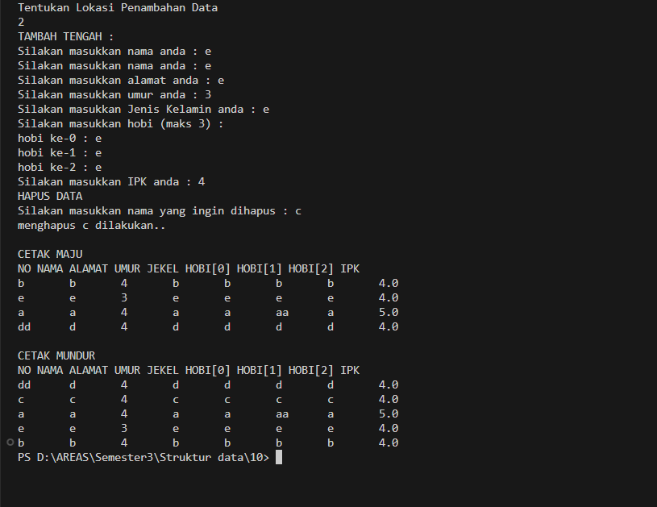

Praktik 3

Praktik 4

Praktik 5

LATIHAN
Latihan 1

-
TUGAS
Tugas 1
-

